**Digital Design and Computer Organization Laboratory**

**UE20CS206**

**3rd Semester, Academic Year 2021-22**

Date: 20-10-21

|  |  |  |
| --- | --- | --- |
| Name : SUNDEEP A | SRN : PES1UG20CS445 | Section : H |

Week : 6

**Title of the Program: Program Counter**

**Code:**

**In pc.v file:**

module adder(input wire a,b,c,output wire sum,cout);

wire t1,t2,t3;

xor2 x1(a,b,t1);

xor2 x2(t1,c,sum);

and2 a1(a,b,t2);

and2 a2(b,c,t3);

and2 a3(a,c,t4);

or2 o1(t2,t3,t5);

or2 o2(t5,t4,cout);

endmodule

module pc_first(input wire clk,reset,load,inc,offset,sub,output wire

pc,cout);

wire or_output,xor_output,adder_out;

or2 o1(offset,inc,or_output);

xor2 x1(or_output,sub,xor_output);

adder a_1(xor_output,sub,pc,adder_out,cout);

dfrl d1(clk,reset,load,adder_out,pc);

endmodule

module pc_ahead(input wire clk,reset,load,inc,offset,sub,cin,output

wire pc,cout);

wire and_output,xor_output,adder_out,incnot;

invert i1(inc,incnot);

and2 a1(offset,incnot,and_output);

xor2 x1(and_output,sub,xor_output);

adder a_1(xor_output,cin,pc,adder_out,cout);

dfrl d1(clk,reset,load,adder_out,pc);

endmodule

module pc(input wire clk, reset, inc, add, sub, input wire [15:0]

offset, output wire [15:0] pc);

wire temp,load;

wire[15:0] c;

or2 o1(inc,add,temp);

or2 o2(temp,sub,load);

pc_first p0(clk,reset,load,inc,offset[0],sub,pc[0],c[0]);

pc_ahead p1(clk,reset,load,inc,offset[1],sub,c[0],pc[1],c[1]);

pc_ahead p2(clk,reset,load,inc,offset[2],sub,c[1],pc[2],c[2]);

pc_ahead p3(clk,reset,load,inc,offset[3],sub,c[2],pc[3],c[3]);

pc_ahead p4(clk,reset,load,inc,offset[4],sub,c[3],pc[4],c[4]);

pc_ahead p5(clk,reset,load,inc,offset[5],sub,c[4],pc[5],c[5]);

pc_ahead p6(clk,reset,load,inc,offset[6],sub,c[5],pc[6],c[6]);

pc_ahead p7(clk,reset,load,inc,offset[7],sub,c[6],pc[7],c[7]);

pc_ahead p8(clk,reset,load,inc,offset[8],sub,c[7],pc[8],c[8]);

pc_ahead p9(clk,reset,load,inc,offset[9],sub,c[8],pc[9],c[9]);

pc_ahead p10(clk,reset,load,inc,offset[10],sub,c[9],pc[10],c[10]);

pc_ahead p11(clk,reset,load,inc,offset[11],sub,c[10],pc[11],c[11]);

pc_ahead p12(clk,reset,load,inc,offset[12],sub,c[11],pc[12],c[12]);

pc_ahead p13(clk,reset,load,inc,offset[13],sub,c[12],pc[13],c[13]);

pc_ahead p14(clk,reset,load,inc,offset[14],sub,c[13],pc[14],c[14]);

pc_ahead p15(clk,reset,load,inc,offset[15],sub,c[14],pc[15],c[15]);

endmodule

**Output waveform:**

**In Terminal**

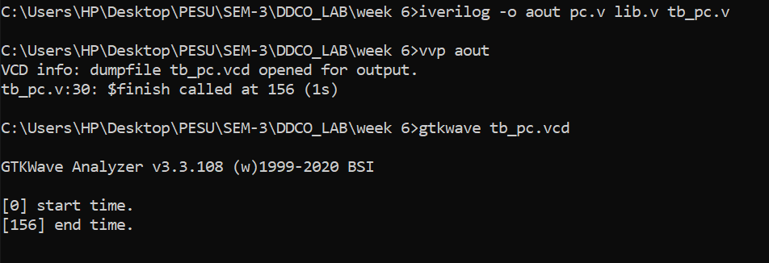

**Gtkwave**

